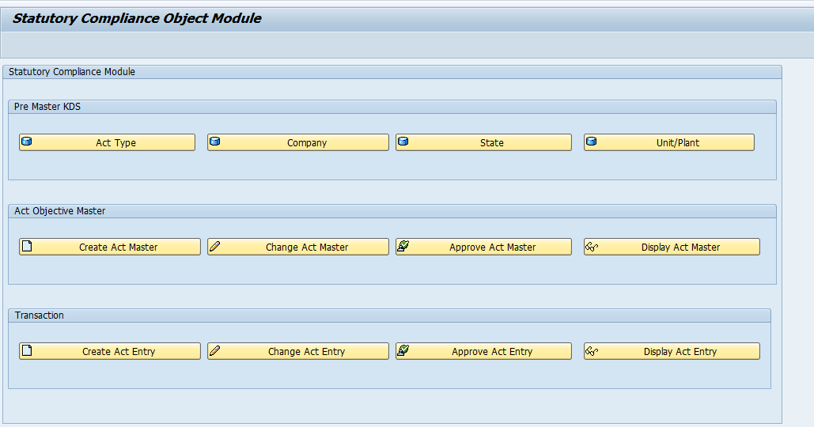

**Statutory Compliance Module:**

**The Transaction code: ZCOMPLIANCE**